Developing an Online Presentation on
Cooking Food Using a Microwave Oven

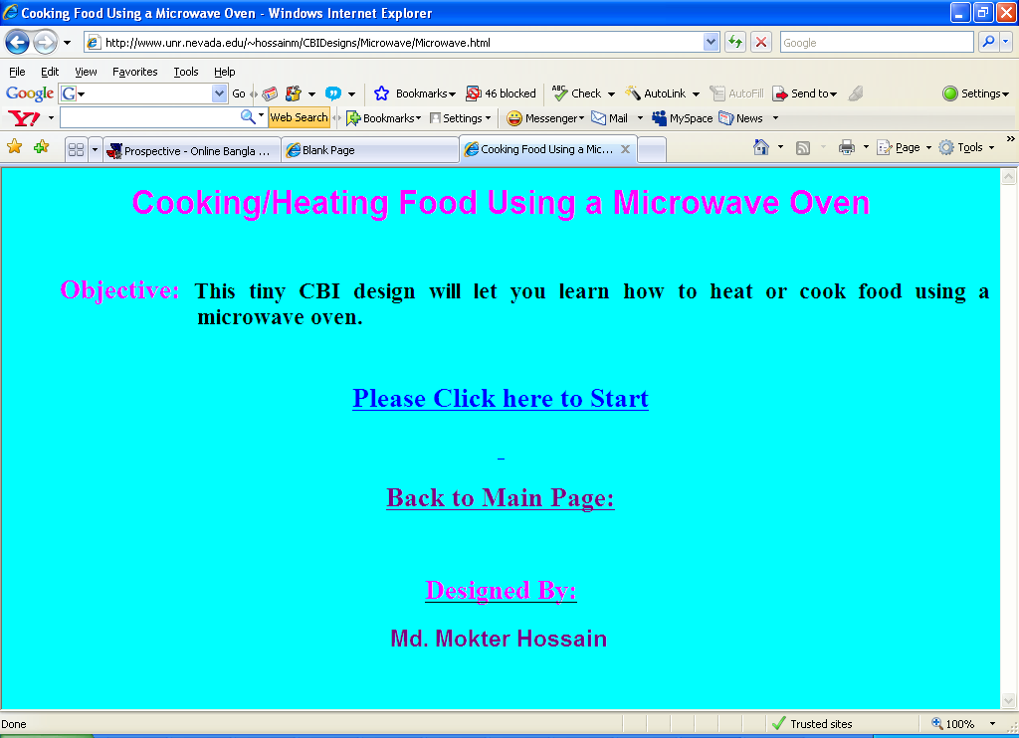
URL: http://www.unr.nevada.edu/~hossainm/CBIDesigns/Microwave/Microwave.html
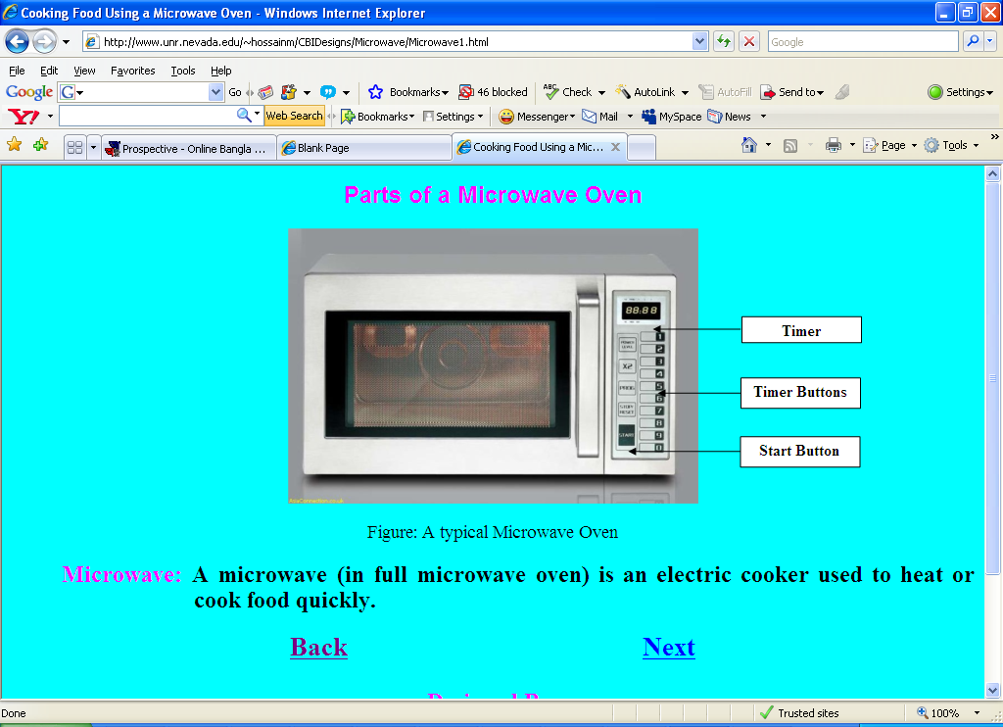
Picture: Parts of a Microwave Oven

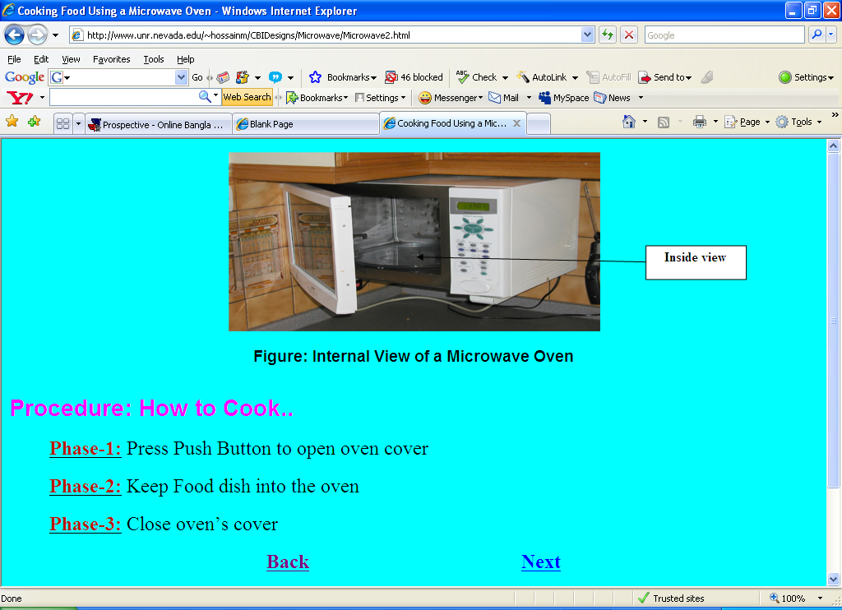
Picture-3: Phases 1 to 3

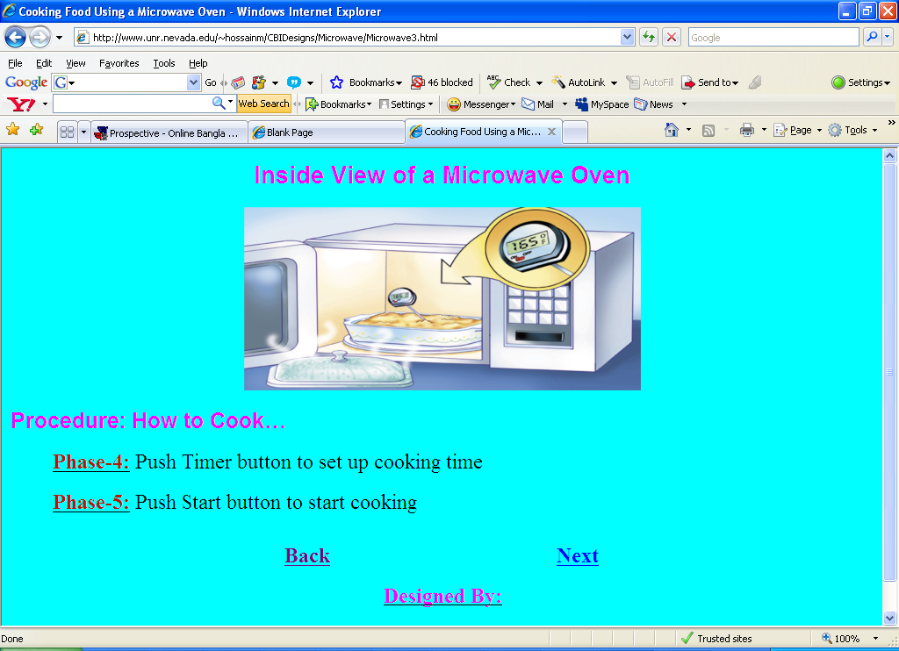
Picture-4: Phases 4 & 5

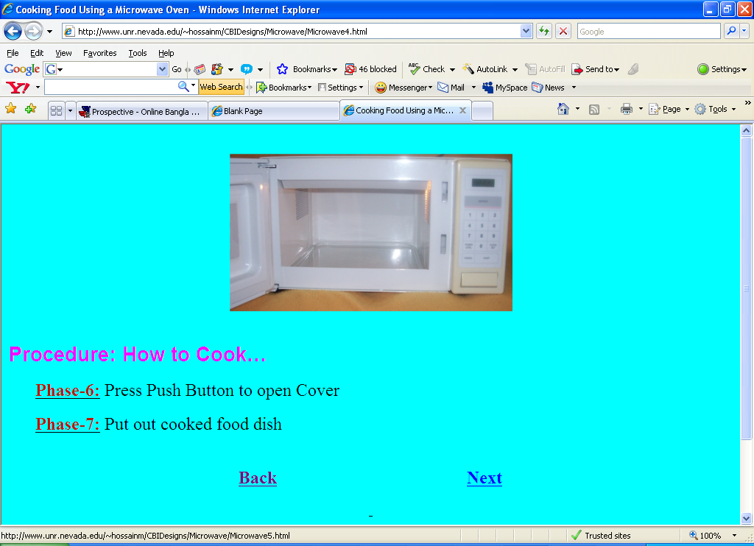
Picture-5: Phases 6 & 7

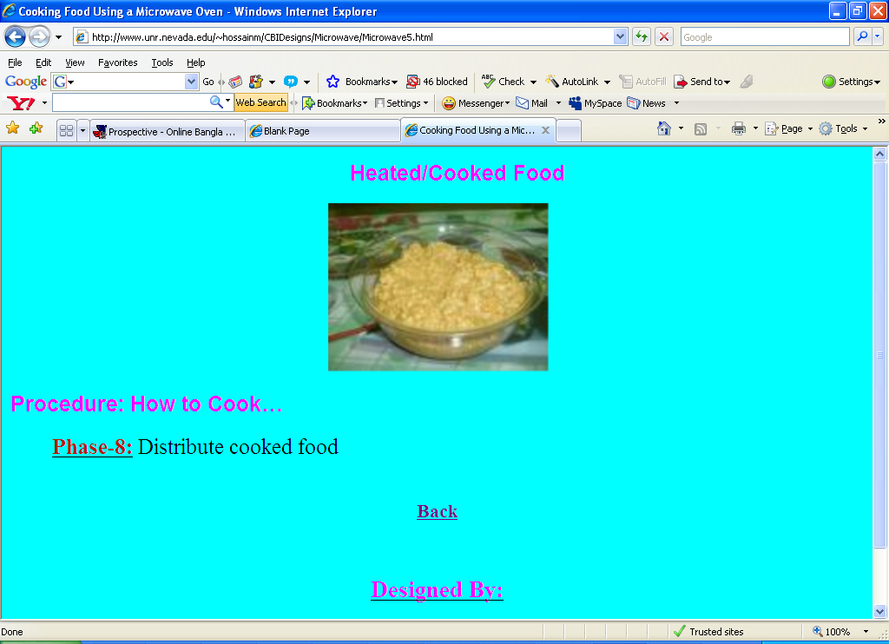
Picture-4: Phase 8

